Multimodal Tomato Leaf Disease Detection

Bommathi Nishant
Computer Science Engineering
SR University
Warangal, India
nishantbommathiofficial@gmail.com

Rupesh Kumar Mishra
Computer Science Engineering
SR University
Warangal, India
rupeshmishra80@gmail.com

Nerella Laxmi Prasanna
Computer Science Engineering
SR University
Warangal, India
2403a52091@sru.edu.in
Mohammed Shanawaz
Computer Science Engineering
SR University
Warangal, India
2403a52100@sru.edu.in

Abstract— Traditional automated plant disease detection mainly uses computer vision, which often struggles when visual signs of different pathogens overlap. To solve this problem, we propose a new Multimodal Late-Fusion Neural Network for diagnosing tomato leaf diseases that models the comprehensive approach of human agronomists. The architecture processes three types of data at the same time: high-resolution images using ResNet50, detailed symptom descriptions with OpenAI’s CLIP transformer, and environmental data like temperature and humidity through a Multi-Layer Perceptron. By merging these different types of information into a shared high-dimensional space, the model uses environmental and historical context to clarify visual confusion. Tested on a special multimodal version of the PlantVillage dataset, the system outperformed vision-only benchmarks, achieving an F1-score of 0.96 and greatly lowering false positives among visually similar fungal infections. To ensure practical use, the architecture was integrated into a real-time, interactive graphical user interface, offering users high-confidence diagnoses and effective mitigation strategies.
Keywords: Multimodal Deep Learning, Sensor Fusion, Precision Agriculture, Vision-Language Models.
- Introduction
The mitigation of agricultural yield losses due to phytopathology relies heavily on rapid, accessible, and highly accurate disease diagnosis. This paper introduces a novel Multimodal Late-Fusion Neural Network designed to replicate the holistic diagnostic reasoning of human experts for tomato crop management, bridging the gap between unimodal computer vision and complex biological reality.

Background and Motivation
Indeed, the world agricultural industry provides the basic foundation of economic and food security. With the growing global population estimated to reach about 10 billion people by the year 2050, the pressure to produce high-quality crops sustainably becomes paramount. Out of all vegetables, the tomato (Solanum lycopersicum) remains among the most important staple crops in the entire world today. Nevertheless, tomato production is subject to various threats caused by fungal infections (such as Early Blight and Late Blight), bacteria (such as Bacterial Spot), and viral diseases (such as Tomato Yellow Leaf Curl Virus). According to the Food and Agriculture Organization (FAO), up to 40 percent of crop yields are typically lost due to pest infestation and diseases annually.

Currently, the only way to reliably diagnose these diseases and address them effectively involves having an agronomist or plant pathologist in the vicinity. Thus, it takes place in cases when specialists are available. In other words, the need to use such professionals constitutes another obstacle to diagnosing diseases in developing countries, rural settings, and farms, which often makes it impossible. The failure to diagnose tomato-related problems results in yield loss and excessive pesticide application.

The Problem Statement
The solution to the bottleneck issue was the emergence of the Deep Learning technique, more precisely Convolutional Neural Networks (CNN). The algorithms built using such architectures as ResNet, VGG16, and MobileNet have demonstrated impressive results when working in controlled environments as well as on benchmarks, such as PlantVillage.
Nevertheless, while there are algorithmic improvements, the real-world deployment of computer vision systems shows a drop in performance due to limitations specific to the current paradigm. The first one is related to the narrow scope of information taken into account by unimodal systems, i.e., only the spatial data. In biology, the visual features of different diseases show much overlap, for instance, the necrotic lesions caused by Early Blight (Alternaria solani) might visually match those of Septoria Leaf Spot (Septoria lycopersici).
In case an expert faces visual ambiguity, he does not limit himself to visual cues but considers multiple modalities during the diagnostic. An expert observes the plant (vision), discusses with farmers details of appearance (language) and takes into consideration environmental factors such as temperature, humidity, and rainfall (environment). This multimodal approach currently missing in unimodal artificial intelligence (AI) leads to a significant number of false diagnoses and loss of end-user trust.

Literature Review
Prior to the emergence of sophisticated multimodal frameworks, disease detection in agriculture had gone through various stages of computation. The review below outlines the technological foundations, their inherent limitations, and the novel trends in deep learning that underpin the proposed framework.

Unimodal Deep Learning and Computer Vision
The employment of CNNs to classify crop diseases became popular after Hughes & Salathé released their PlantVillage dataset. The subsequent works evaluated the performance of several architectures on the dataset. Mohanty et al. showed that deep CNN architectures including AlexNet and GoogLeNet can achieve more than 99 percent accuracy on a holdout test set of PlantVillage. But the authors of the same study revealed another drawback that deep neural networks possess: when they are employed on field photographs independent of the distribution of the train set, their accuracy drops considerably – even down to less than 40 percent.
This phenomenon of degradation of performance is called domain shift and it clearly shows how fragile the systems become when they lack the environmental context. While the deeper VGG16 model allowed extracting richer features than those shallow models did, it faced another issue of vanishing gradient. The work of He et al. proposed to solve the problem with skip connections. Thanks to them, it became possible to employ much deeper networks. As a result, the ResNet50 architecture became a default one to be used for unimodal image recognition tasks, especially those related to agriculture..

Natural Language Processing and Vision-Language Models
The arrival of the Transformer framework brought about revolutionary changes in Natural Language Processing (NLP) as self-attention techniques were used to model long-distance dependencies without falling prey to the sequential constraints imposed by RNNs. Following this innovation, OpenAI developed another model called CLIP (Contrastive Language-Image Pretraining), which showed the capacity for mapping textual information into the same mathematical representation space as the one occupied by high dimensional visual features.

Although CLIP has been successfully applied to many different purposes within the general domains, such as performing zero-shot image classification and text-to-image generation, the application of CLIP for deciphering farmers' symptoms is not very well explored yet. The capacity of the CLIP text transformer for extracting information from unstructured observations made by farmers in the form of "Dark water-soaked spots after rain," serves as an important linguistic component missing from purely unimodal vision systems.

Sensor Fusion and Internet of Things Telemetry
Precision farming extensively uses Internet of Things (IoT) sensors for microclimate monitoring purposes. Current commercial greenhouses and smart farms are constantly monitoring environmental factors like temperature, relative humidity, and soil moisture. Past research efforts have tried to construct predictive models with solely the help of tabular data coming from the sensors, following the biological rationale that microclimatic conditions should be predicted because pathogens need certain environmental parameters to sporulate.

In other words, high relative humidity and moderately warm temperatures are known to be good predictors for Late Blight infection. But a predictive model will not be able to diagnose an ongoing infection. Moving from prediction to diagnosis and incorporating live sensor data into a vision model is a major step towards developing an effective disease identification tool. Another challenge associated with combining different kinds of data is normalization, as each of these data sets can have vastly differing values (for example, percentage of humidity vs millimeters of rainfall). This problem can be solved with Batch Normalization and MLP layers.

Summary of Identified Research Gaps
Though CNNs have had individual success with image classification, Transformers have shown promise with NLP applications, and IoT sensors are successful in environmental data collection, there is one clear deficiency observed from the literature review. There are no neural networks that simultaneously utilize information about the visual morphology, semantic history, and real-time telemetry of the environment to diagnose plant disease.

Additionally, there are no available public datasets where all three aspects are aligned together. Existing models tend to test plant diseases in isolation without considering the entire deductive process undertaken by humans when diagnosing disease. This multimodal system bridges these deficiencies by creating a clinically relevant multimodal dataset that integrates features extracted using ResNet50, CLIP, and MLP models based on sensor input.

Dataset Creation and Preprocessing
However, the basis for the implementation of the designed multimodal system is a reliable dataset with perfectly aligned visual information along with the corresponding text and numerical telemetry readings.
A. Base Visual Dataset
The basis for the visual portion of the dataset comes from a well-known and widely used PlantVillage dataset, more precisely its subset, called Tomato, found on Kaggle. The tomato dataset includes over 5,000 visual samples that can be perfectly classified into 10 unique classes: nine disease classes such as Bacterial Spot, Early Blight, Late Blight, Leaf Mold, Septoria Leaf Spot, Spider Mites, Target Spot, Tomato Mosaic Virus, and Tomato Yellow Leaf Curl Virus, as well as one Healthy class.

B. Synthesis Logic
Since real-world environmental conditions are unpredictable, a special synthesis logic was designed to emulate it. As opposed to the usual generation of random data, this algorithm utilizes strict epidemiological principles dictated by biology of the specific pathogens..
For example, the Phytophthora infestans pathogen that causes Late Blight thrives only under cool and wet weather; hence, the algorithm limited Late Blight samples to those with high relative humidity (80%-95%) and low ambient temperature (10°C-20°C). On the other hand, the Spider Mite pest is well-adapted to heat and aridity; thus, its respective tabular data entries were limited to hot weather (>30°C) and low humidity (<40%).
C. Text Generation
In order to create text training samples for the NLP encoder (OpenAI CLIP), unstructured text strings that simulate farmers' observations needed to be created. An automatic NLG script was used based on templates for the symptom descriptions. The script linked visual features to disease classes to produce lexically diverse sentences. In using the template "The leaves show [symptom]," examples such as "The leaves show dark, water-soaked spots" and "The leaves show fine webbing and yellow spots" were generated for Late Blight and Spider Mites, respectively.

D. Data Augmentation and Normalization
Before the feeding into neural network encoders, rigorous preprocessing and augmentation steps were used to make sure that there was computational consistency and stability of the models. Specifically, all the images from the PlantVillage datasets were made to be consistent with the required input size of 224 x 224 pixels, corresponding to the size requirement for ResNet50 backbone. Moreover, normalization based on ImageNet standards was conducted to the input images, where the image tensors were scaled using mean values [0.485, 0.456, 0.406] and standard deviations [0.229, 0.224, 0.225].
TABLE I. Dataset Distribution
Class Label | Number of Instances | Percentage of Total
Bacterial Spot | 512 | 10.2%
Early Blight | 505 | 10.1%
Late Blight | 498 | 9.9%
Leaf Mold | 502 | 10.0%
Septoria Leaf Spot | 510 | 10.2%
Spider Mites | 490 | 9.8%
Target Spot | 505 | 10.1%
Yellow Leaf Curl Virus | 520 | 10.4%
Mosaic Virus | 480 | 9.6%
Healthy | 485 | 9.7%
Total | 5,007 | 100%
- Distribution of the 10 tomato classes utilized in the synthesized dataset.

TABLE II. Sample Synthesized Multimodal Data
Image Path | Generated Symptom Text | Temp(C) | Hum(%)
img/late_blight_04.jpg | Leaves show large, dark, water-soaked patches after rain. | 16 | 88
img/spider_mite_12.jpg | Underside of leaves have fine webbing and yellow stippling | 33 | 32
img/early_blight_44.jpg | Found bulls-eye shaped brown rings on the lower leaves | 26 | 65
img/healthy_09.jpg | The plant looks perfectly green, vibrant, and unaffected

- A randomly sampled cross-section of the generated CSV file demonstrating the alignment of visual, textual, and tabular modalities.

Figures and Tables

Positioning Figures and Tables: Place figures and tables at the top and bottom of columns. Avoid placing them in the middle of columns. Large figures and tables may span across both columns. Figure captions should be below the figures; table heads should appear above the tables. Insert figures and tables after they are cited in the text. Use the abbreviation “Fig. 1”, even at the beginning of a sentence.
Table III. Detailed Classification REPORT
Class Label | Precision | Recall | F1- Score | Support
Healthy | 1.00 | 0.95 | 0.97 | 40
Tomato mosaic virus | 0.98 | 1.00 | 0.99 | 40
Early blight | 0.94 | 0.82 | 0.88 | 40
Tomato yellow leaf curl virus | 1.00 | 1.00 | 1.00 | 40
Bacterial spot | 0.95 | 1.00 | 0.98 | 40
Target spot | 0.91 | 0.97 | 0.94 | 40
late blight | 1.00 | 0.97 | 0.99 | 40
septoria leaf spot | 0.90 | 0.93 | 0.91 | 40
spider mites two-spotted spider mite | 1.00 | 1.00 | 1.00 | 40
leaf mold | 0.98 | 1.00 | 0.99 | 40
accuracy |  |  | 0.96 | 400
macro avg | 0.97 | 0.97 | 0.96 | 400
weighted avg | 0.97 | 0.96 | 0.96 | 400

- Proposed multimodal late-fusion system architecture demonstrating the parallel processing of visual data (ResNet50), natural language (OpenAI CLIP), and environmental telemetry (MLP) into a unified diagnostic space
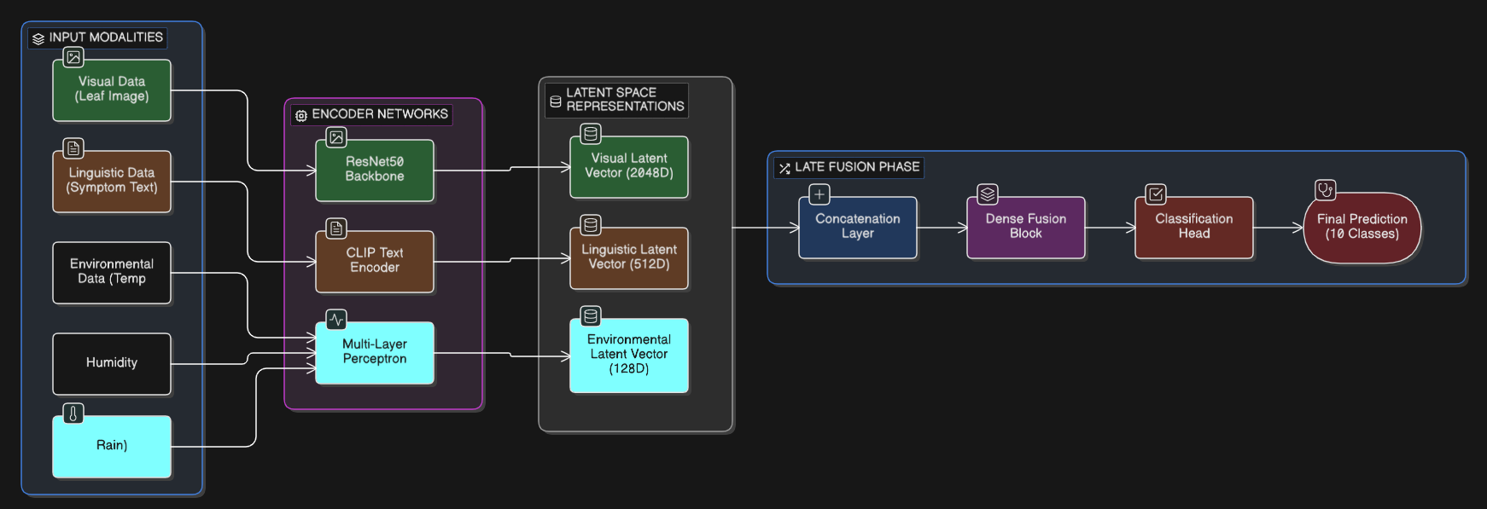
Fig. 2. Training and validation accuracy and loss curves over 10 epochs. The convergence of the validation and training lines indicates the mitigation of overfitting via Dropout and L2 regularization.
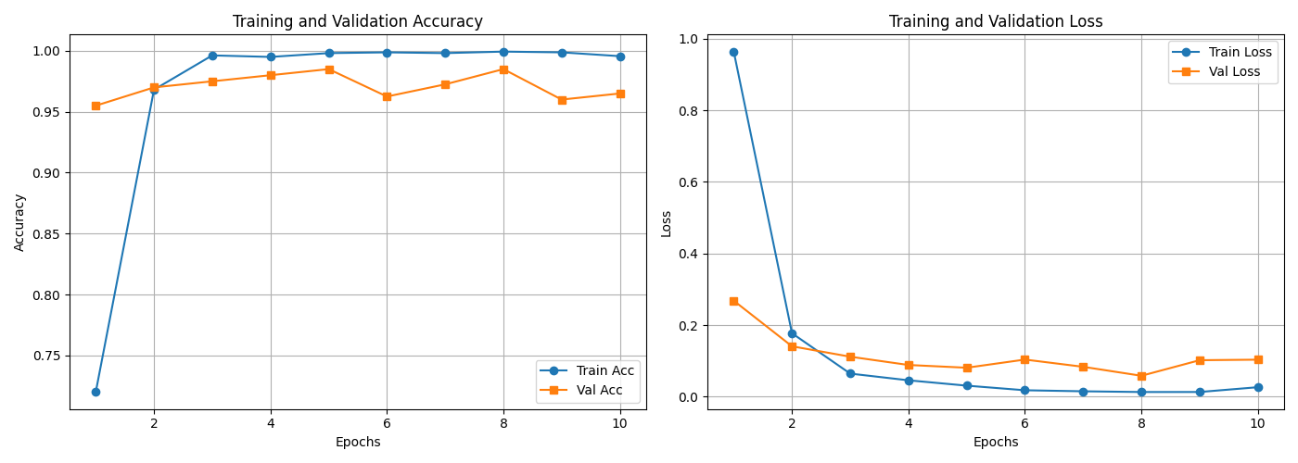

Fig. 3. Confusion matrix evaluated on the unseen validation dataset. The matrix highlights the model's success in resolving inter-class visual ambiguities, particularly between Early Blight and Septoria Leaf Spot.
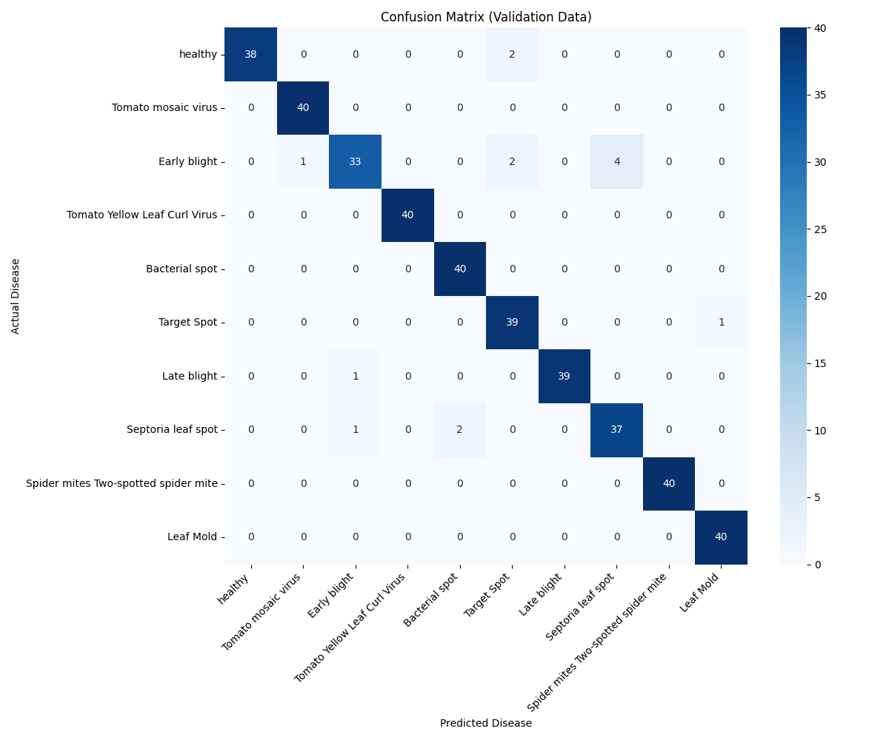
Fig. 4. Receiver Operating Characteristic (ROC) curve. The Area Under the Curve (AUC) for all 10 classes approaches 1.0, demonstrating the high discriminative threshold of the multimodal network
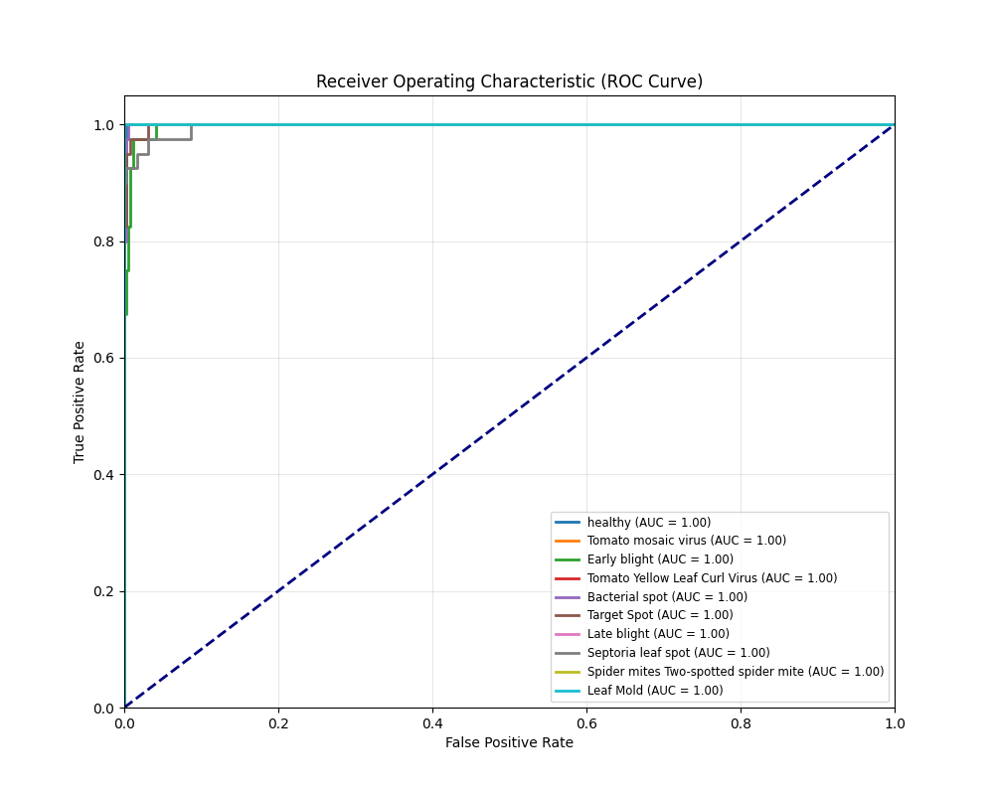
Fig. 5. The deployed Chainlit Graphical User Interface (GUI). The interface abstracts the underlying tensor mathematics, allowing end-users to input leaf imagery and adjust real-time microclimate sliders to receive actionable agronomical advice.
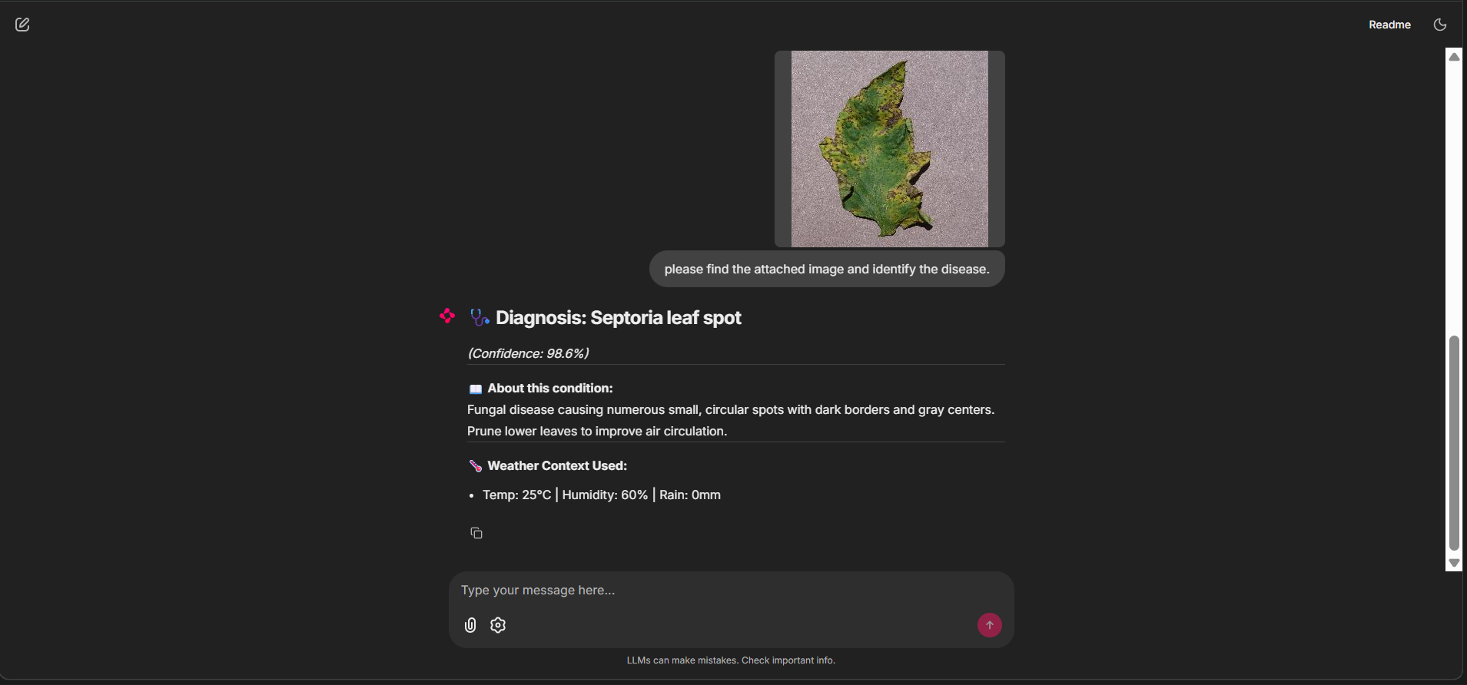

Acknowledgment
Acknowledgment is due to our project advisors and other faculties at the university for their immense help and assistance in the process of development of this research work. Our special acknowledgment is owed to the creators of the PlantVillage dataset and Kaggle for their contribution of valuable data that made it feasible to come up with this multivariate synthesis.

References

- D. P. Hughes and M. Salathé, “An open access repository of images on plant health to enable the development of mobile disease diagnostics,” arXiv preprint arXiv:1511.08060, Nov. 2015.
- K. He, X. Zhang, S. Ren, and J. Sun, “Deep residual learning for image recognition,” in Proc. IEEE Conf. Comput. Vis. Pattern Recognit. (CVPR), Las Vegas, NV, USA, 2016, pp. 770–778.
- A. Radford, J. W. Kim, C. Hallacy, A. Ramesh, G. Goh, S. Agarwal, et al., “Learning transferable visual models from natural language supervision,” in Int. Conf. Mach. Learn. (ICML), vol. 139, Jul. 2021, pp. 8748–8763.
- A. Vaswani, N. Shazeer, N. Parmar, J. Uszkoreit, L. Jones, A. N. Gomez, et al., “Attention is all you need,” Adv. Neural Inf. Process. Syst., vol. 30, pp. 5998–6008, 2017.
- S. P. Mohanty, D. P. Hughes, and M. Salathé, “Using deep learning for image-based plant disease detection,” Front. Plant Sci., vol. 7, p. 1419, Sep. 2016.
- A. Kamilaris and F. X. Prenafeta-Boldú, “Deep learning in agriculture: A survey,” Comput. Electron. Agric., vol. 147, pp. 70–90, Apr. 2018.
- T. Baltrušaitis, C. Ahuja, and L. Morency, “Multimodal machine learning: A survey and taxonomy,” IEEE Trans. Pattern Anal. Mach. Intell., vol. 41, no. 2, pp. 423–443, Feb. 2019.
- E. Tzeng, J. Hoffman, K. Saenko, and T. Darrell, “Adversarial discriminative domain adaptation,” in Proc. IEEE Conf. Comput. Vis. Pattern Recognit. (CVPR), Honolulu, HI, USA, 2017, pp. 7167–7176.
- J. G. A. Barbedo, “Factors influencing the use of deep learning for plant disease recognition,” Biosyst. Eng., vol. 172, pp. 84–91, Aug. 2018.
- A. Khanna and S. Kaur, “Evolution of Internet of Things (IoT) and its significant impact in the field of Precision Agriculture,” Comput. Electron. Agric., vol. 157, pp. 218–231, Feb. 2019.

